Test performed :

1. Wilcoxon test not possible on the ATTRITION datasheet .
2. Friedman test also not possible .
3. Man Whitney Test

H0 = there is no significant difference in the Monthly income of people who left the company and who are still working .

H1= there is significant difference in the Monthly income of people who left the company and who are still working .

Using Attrition , MonthlyIncome columns .

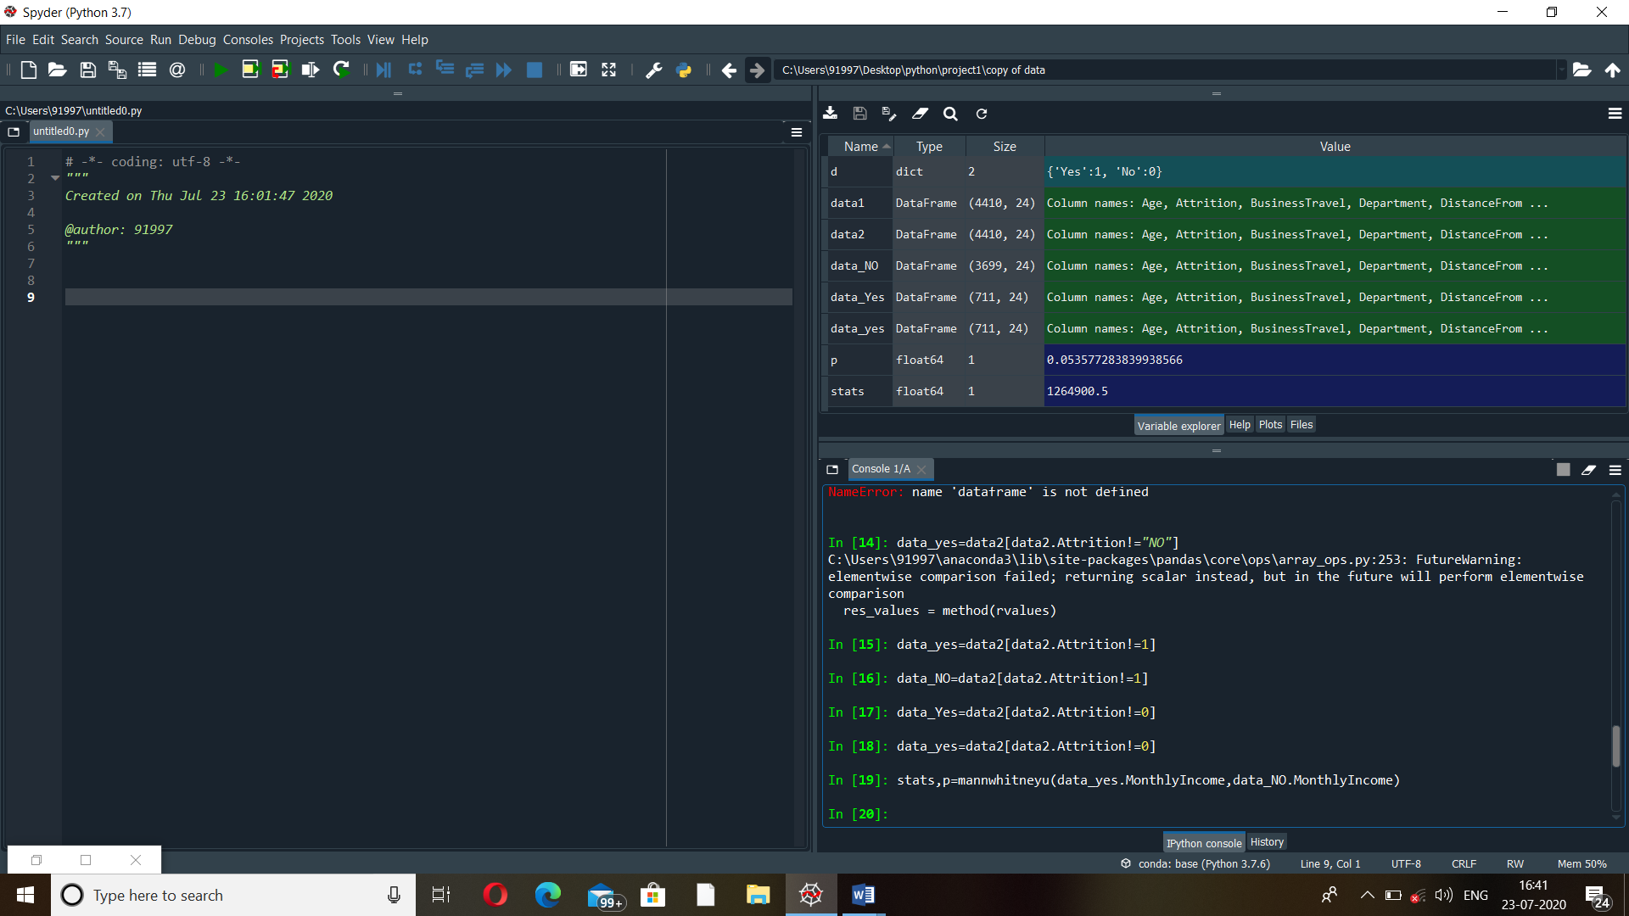

NULL HYPOTHESIS ACCEPTED in this case .

1. Kruskal Wallis test

H0 = There is no significant difference in the Monthly Income of the people working in the company with different Job Level.

H1= There is significant difference in the Monthly Income of the people working in the company with different Job Level.

Using Joblevel , MonthlyIncome column

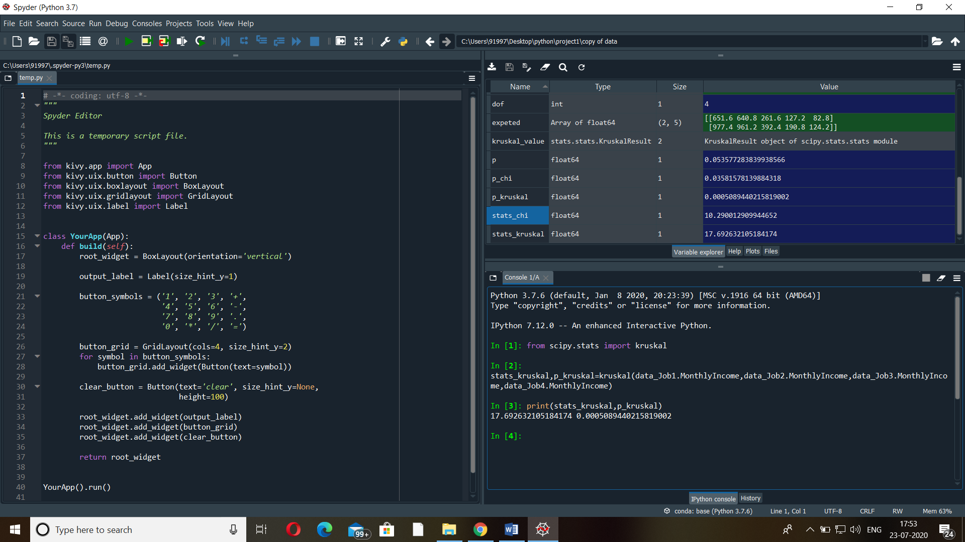

NULL hypothesis is rejected.

1. Chi square Test

H0= there is no dependency between gender and job level.

H1= there is dependency between gender and job level.

Using Gender and Job level columns

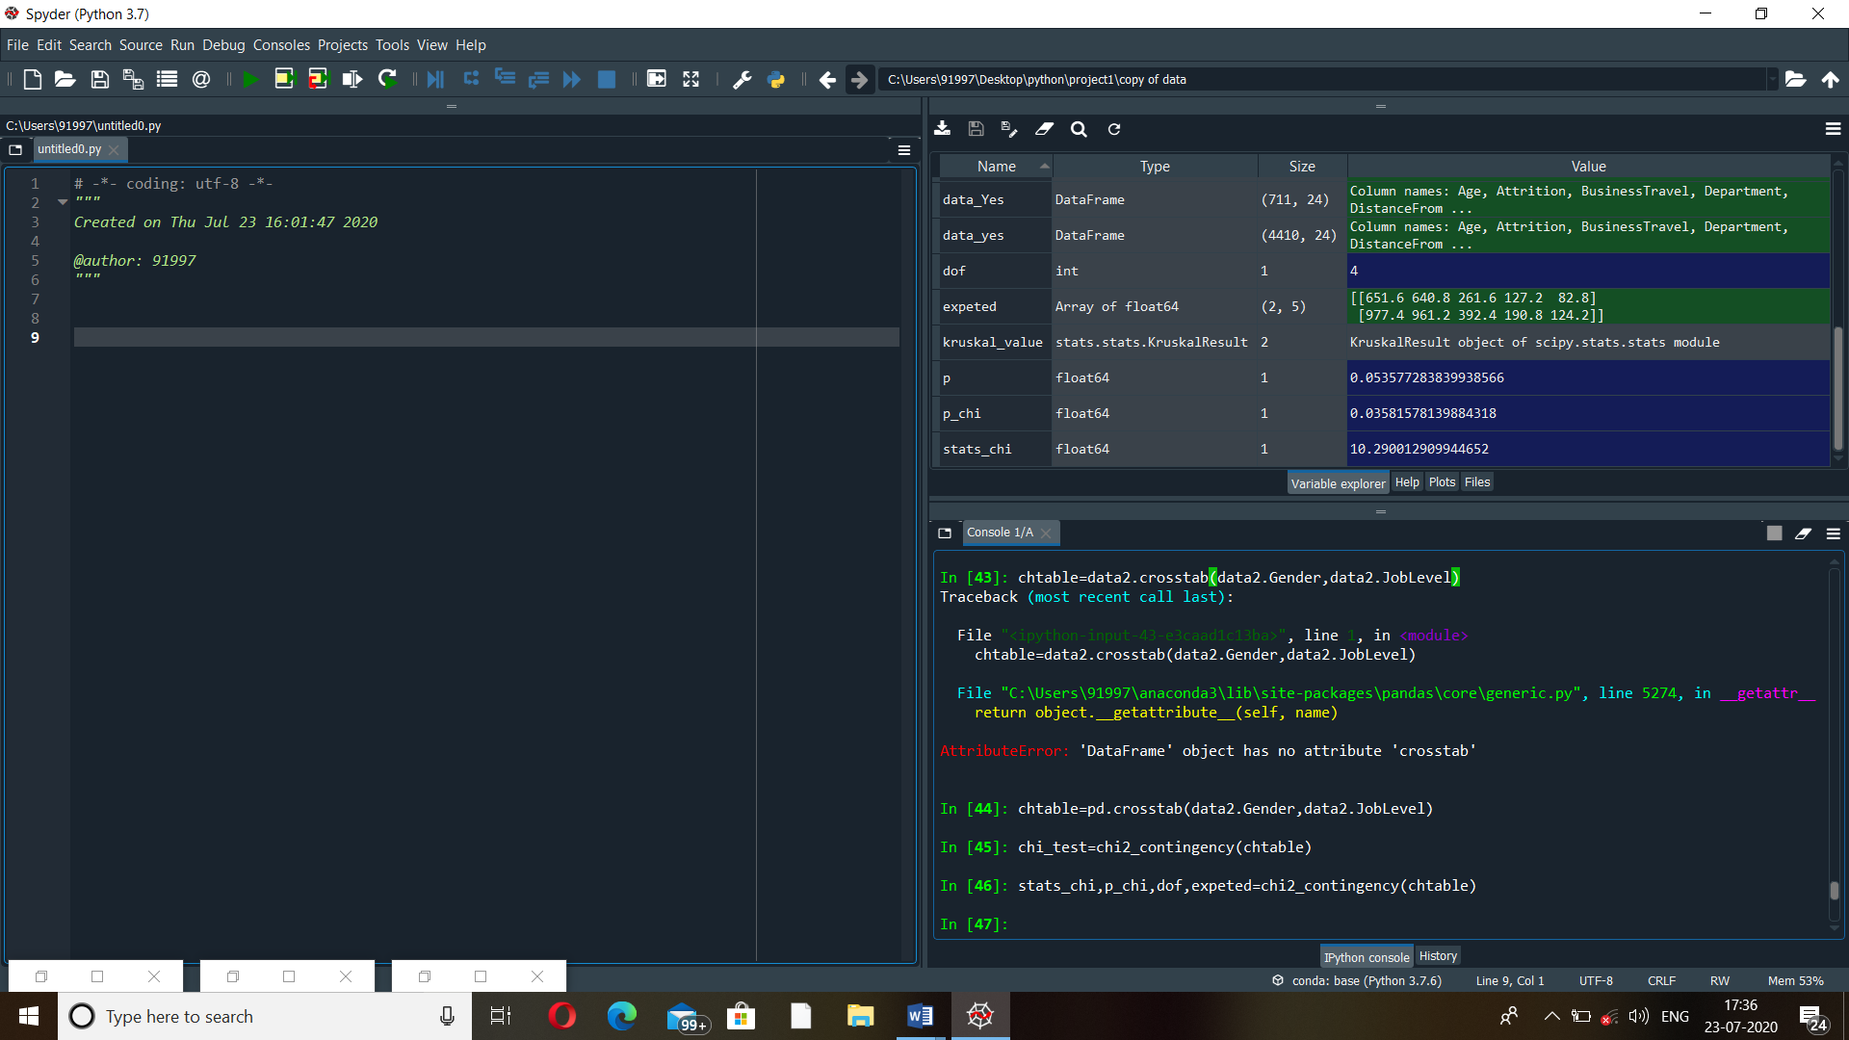

Null hypothesis is rejected.